**CP6 MongoDB Class Participation**

**Course:** BUAN 6320.002

**Course Name:** Database Foundations

**Course Instructor:** Ravishankar Narayan

**Group Name:** Data Mining team

**Group Members:** Darshil Gohel,Sanket Patel

1. Create a database called "ClassicModels"

Query : Use ClassicModels

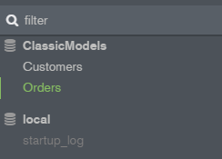

1. Create appropriate collections for "Customers" and "Orders"
2. Create two documents for customer orders that contains two orders and customer details

Adding the data into the collection creates the collection automatically.

Creating the Customer data and adding the details

Query:

db.Customers.insert([

{

customerNumber: 103,

customerName:'Atelier graphique',

contactLastName:'Schmitt',

contactFirstName:'Carine',

phone:'40.32.2555',

addressLine1:'54, Rule Royale',

addressLine2:'NULL',

city:'Nantes',

state:'NULL',

postalCode:44000,

country:'France',

salesRepEmployeeNumber:1370,

creditLimit:21000,

customerLocation:'Germany'

},

{

customerNumber: 112,

customerName:'Signal Gift Stores',

contactLastName:'King',

contactFirstName:'Jean',

phone:'484356565',

addressLine1:'8489, Strongst.',

addressLine2:'NULL',

city:'Las Vegas',

state:'NV',

postalCode:83030,

country:'USA',

salesRepEmployeeNumber:1166,

creditLimit:71800,

customerLocation:'Germany'

}

])

Creating the Order data and adding the details

Query:

db.Orders.insert([

{

orderNo:10100,

orderDate:'2003-06-01',

requiredDate:'2003-01-13',

shippedDate:'2003-01-10',

status:'Shipped',

comments:'check availability',

CustomerNo:'112',

},

{

orderNo:10101,

orderDate:'2003-01-01',

requiredData:'2003-02-01',

shippedDate:'2003-02-03',

status:'Shipped',

comments:'No comments',

CustomerNo:'103',

}

])

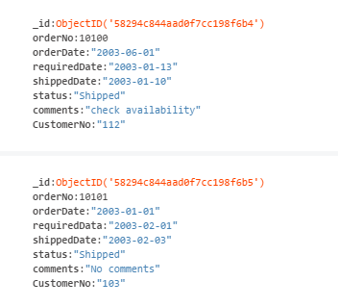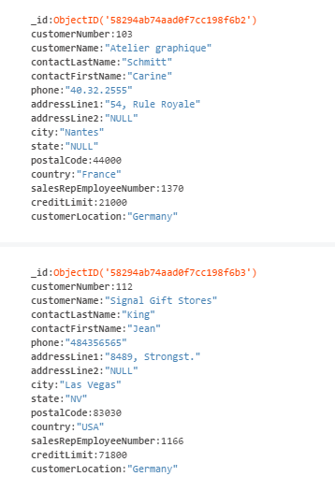

(MongoDB compass screenshots)

1. Retrieve the first customer order in your database that includes both customer and order data

Query:

db.Orders.aggregate([

{

$lookup:

{

from:'Customers',

localField:'CustomerNumber',

foreignField:'CustomerNumber',

as:'customer_data',

}

}

])

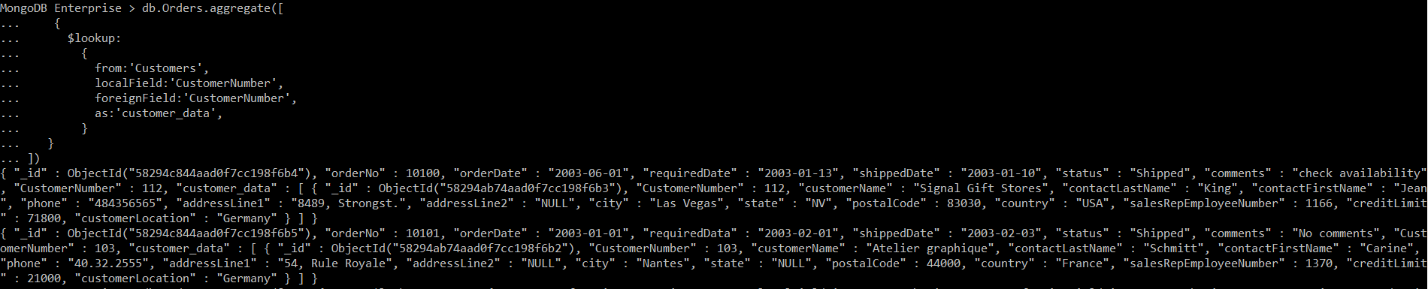

1. Delete the first document in your collection

Query:

db.Orders.remove({orderNo:10100})



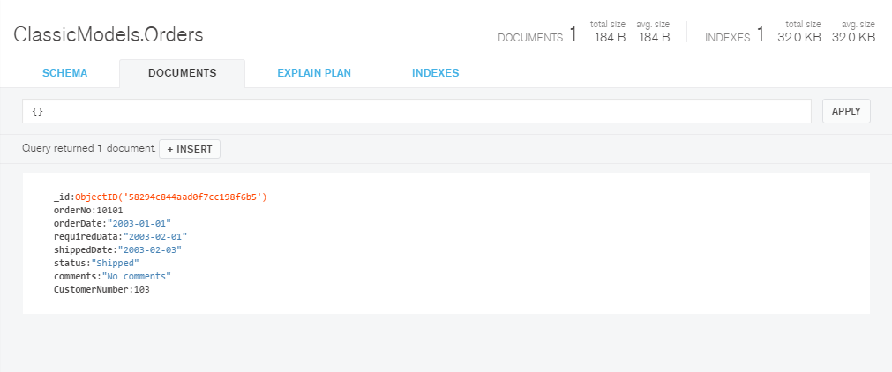

1. Drop the entire collection

Query:

db.Orders.drop()



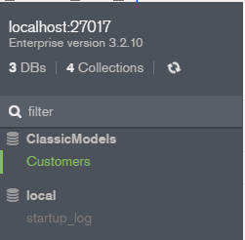

1. Drop the entire database

Query:

db.dropDatabase()



